# Assignment:

# Setting up a GitHub Repository and Cloning it using GitHub Desktop

**Objective:** To learn how to create a new repository on GitHub and clone it to your local system using the GitHub Desktop application.

**Software Required:**

A GitHub account (free or paid).

GitHub Desktop application (download from <https://desktop.github.com/>).

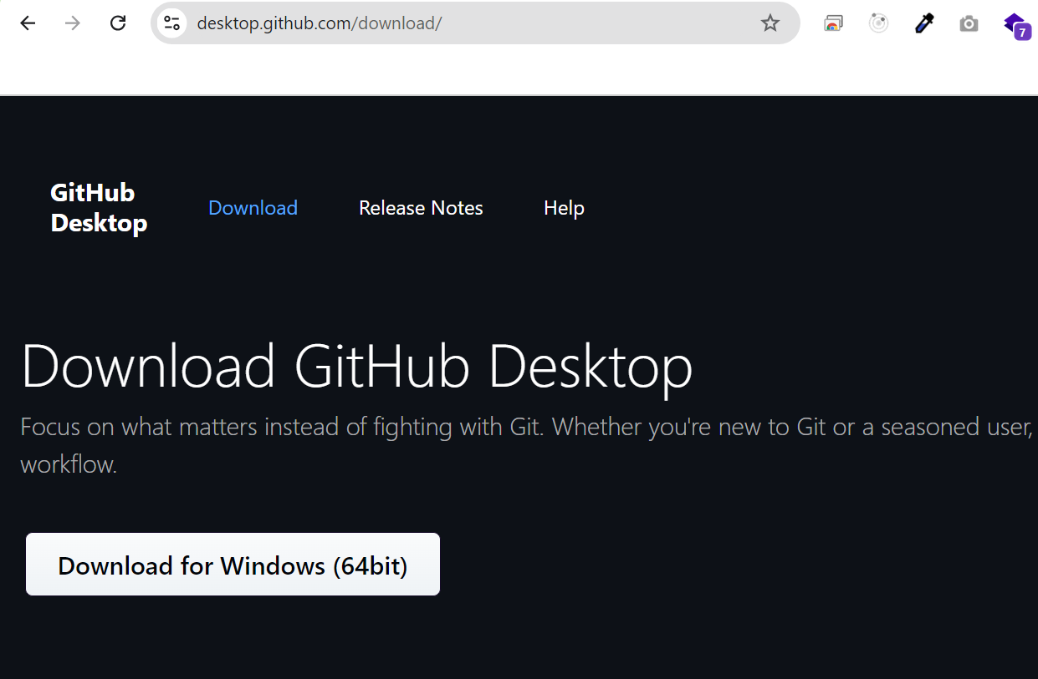

**Part 1: Creating a New Repository on GitHub**

Log in to GitHub: Open your web browser and navigate to https://github.com/. Log in to your GitHub account.

Create a New Repository:

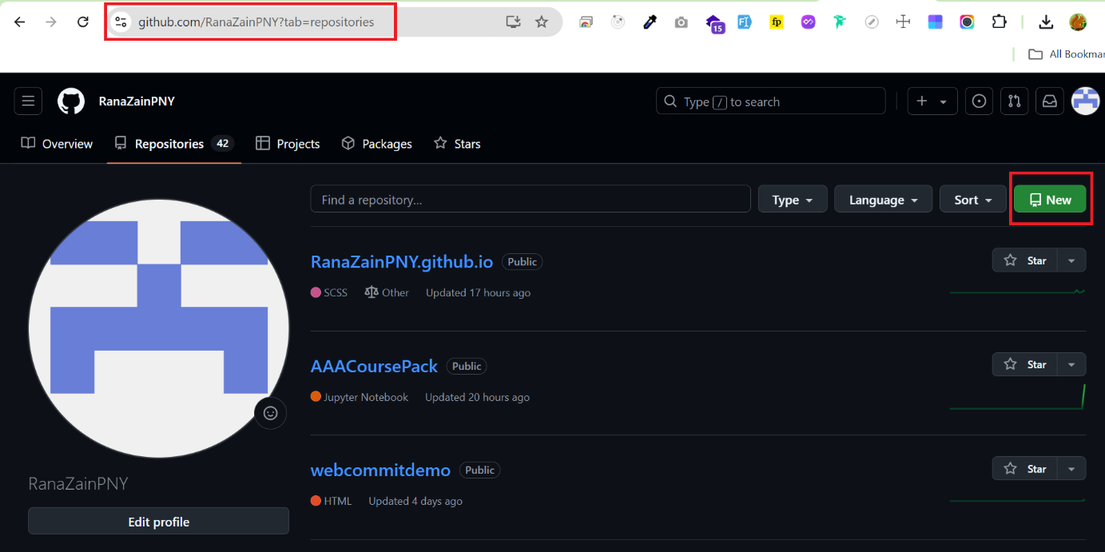

After clicking upon New button this screen will appear.

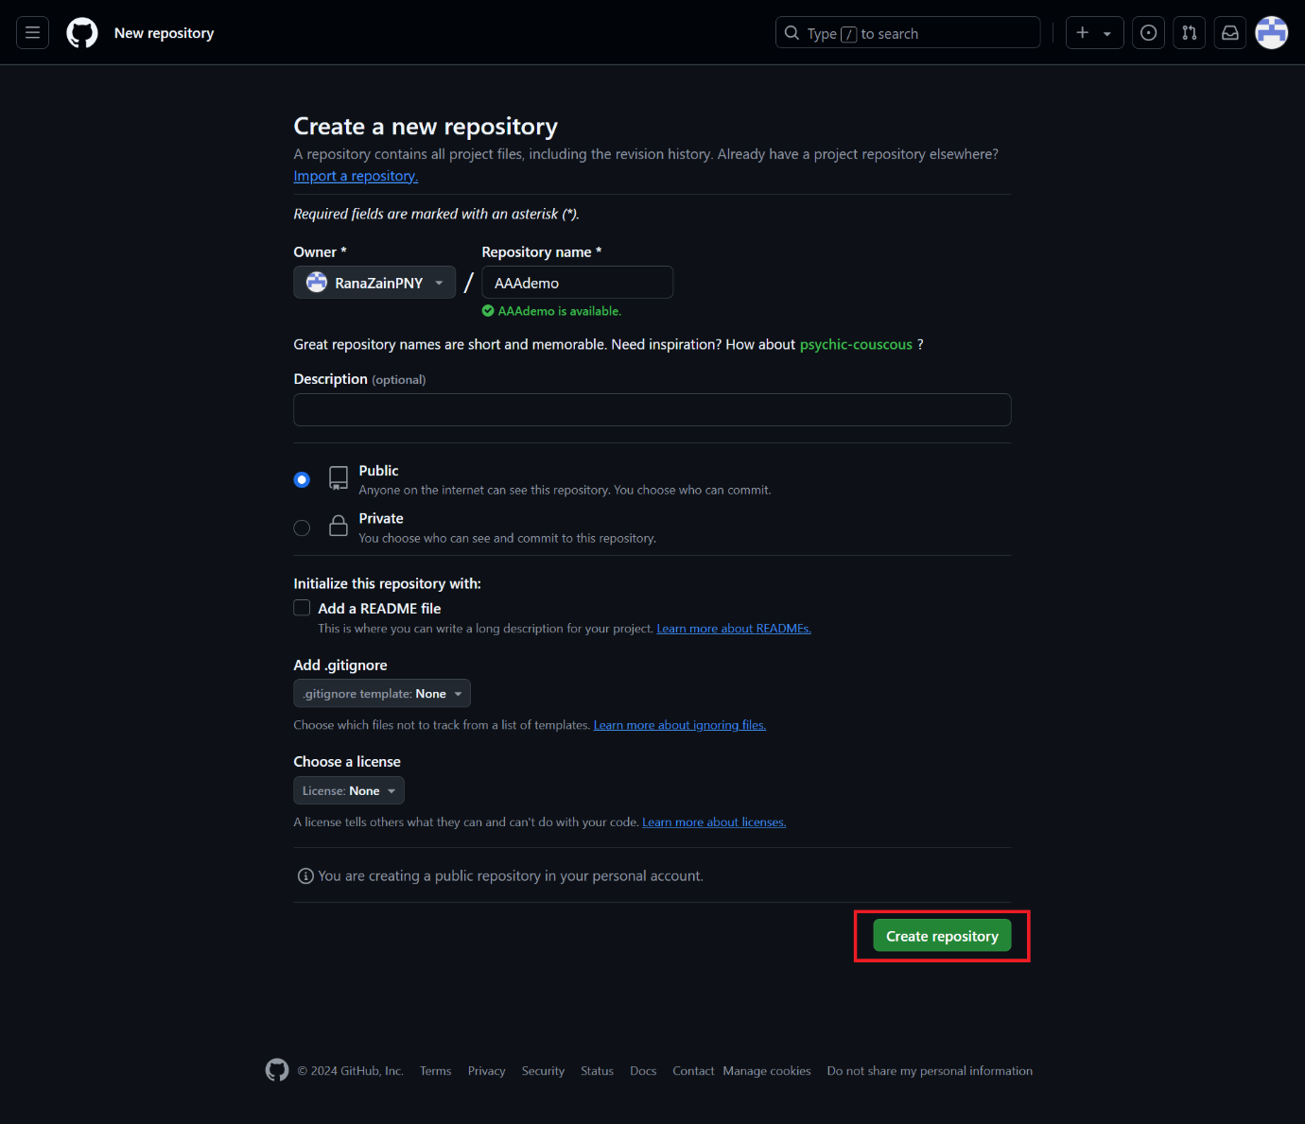

Repository name: Give your repository a descriptive name (e.g., my-first-repo). Make sure the name is unique.

Description (optional): Add a brief description of your repository.

Public/Private: Choose "Public" to make your repository visible to everyone, or "Private" to keep it private (requires a paid GitHub account for private repos).

Add a README file (optional): It's recommended to add a README file to provide information about your project.

Add .gitignore (optional): Select a .gitignore template relevant to your project (e.g., Python, Node.js). This helps exclude unnecessary files from version control.

Add a license (optional): Choose a license that defines how others can use your code.

Click "Create repository."

After clicking Create repository this screen will appear.

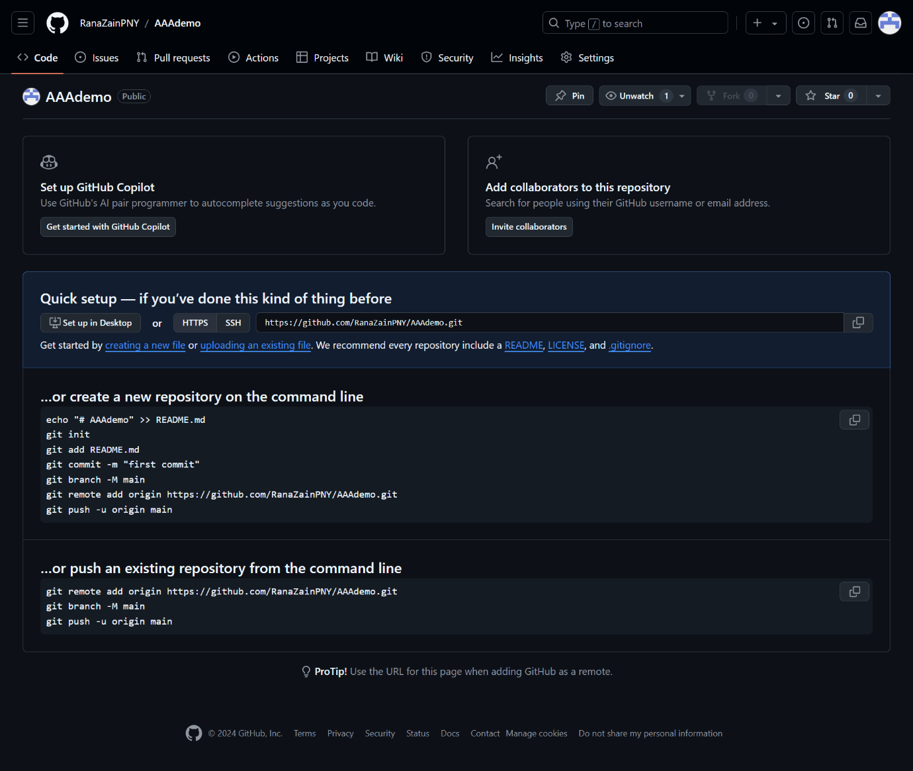

**Part 2: Cloning the Repository using GitHub Desktop**

Open GitHub Desktop: Launch the GitHub Desktop application.

Clone Repository:

Click the "Clone" button in the upper left corner File menu.

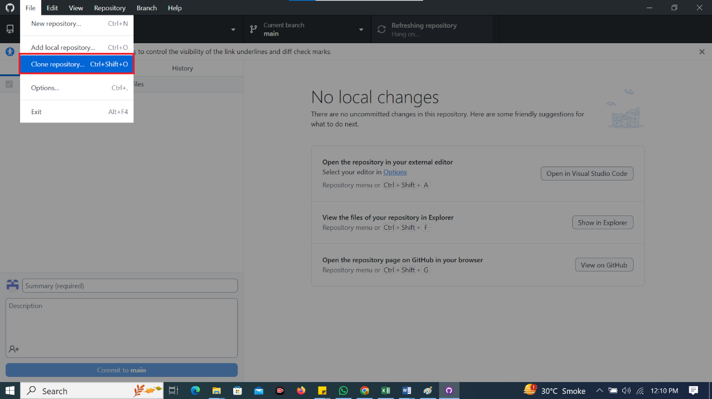

URL: Copy the HTTPS URL of your newly created repository from the GitHub website. Paste it into the "URL" field in GitHub Desktop.

Local Path: Choose a directory on your local system where you want to clone the repository. This is where the project files will be stored.

Click "Clone."

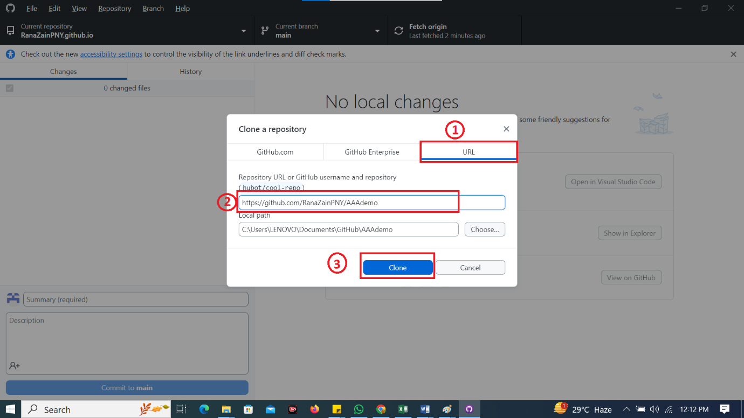

**Part 3: Verification**

Navigate to the Local Directory: Open your file explorer and navigate to the local directory you specified in Step 2 of Part 2. You should see the cloned repository folder.

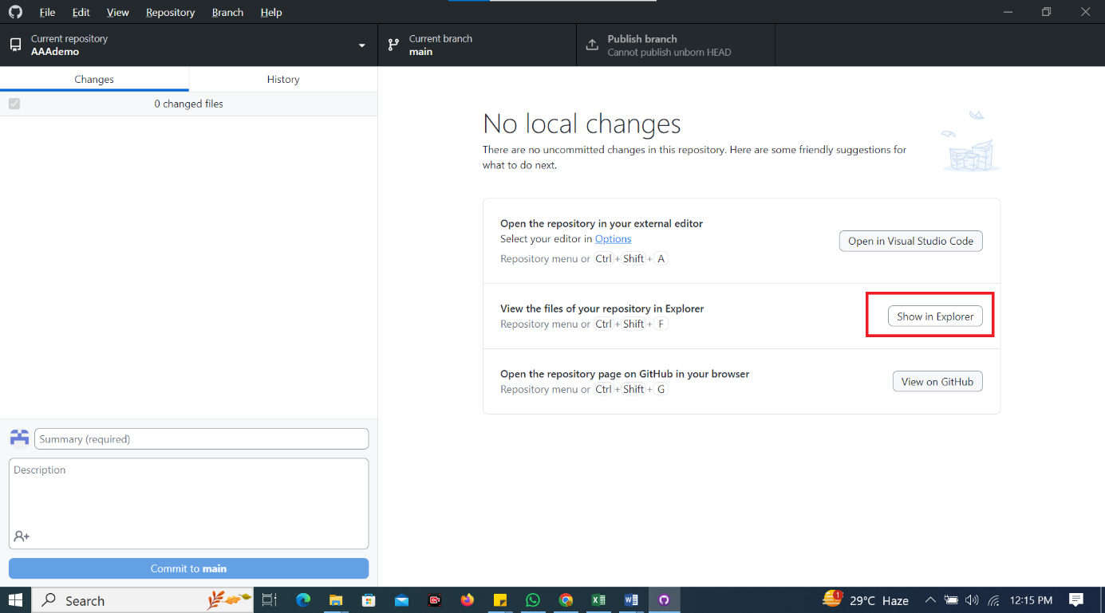

Check the Contents: Open the cloned repository folder. You should see the files you included when creating the repository (e.g., README.md, .gitignore). (Screenshot: Take a screenshot of the cloned repository folder on your local system.)

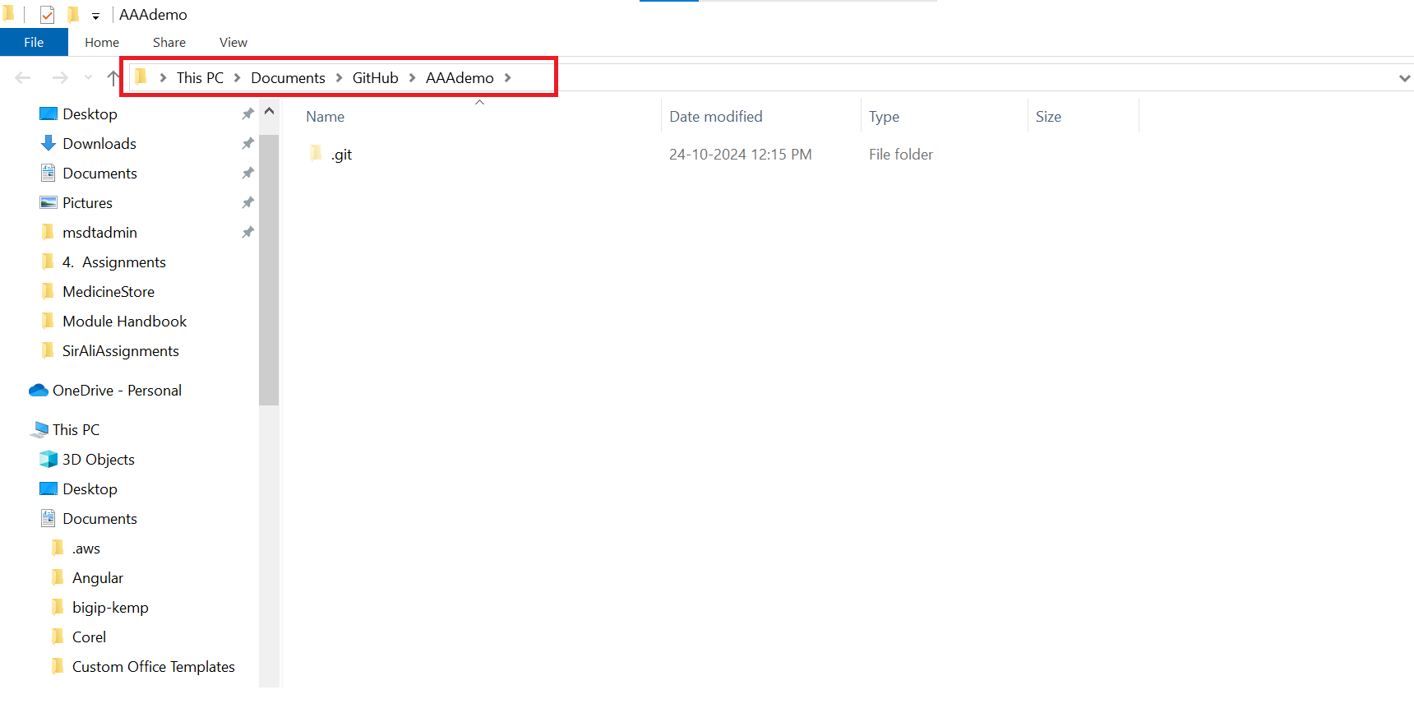

**Part 4: Making Changes and Pushing them to GitHub**

Make a Change: Create a new file and add some text. Save the changes.

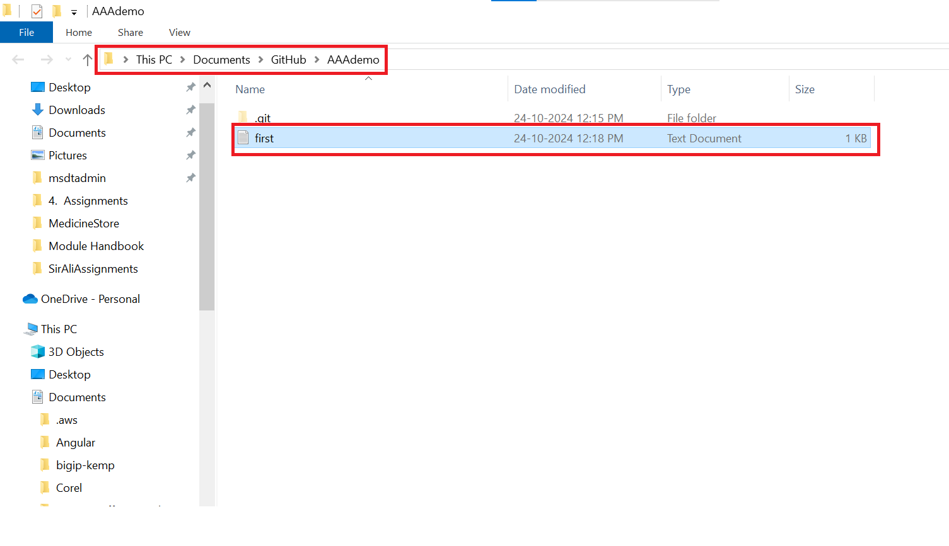

GitHub Desktop should automatically detect the changes. Write a commit message describing your changes (e.g., "Added new text file name first.txt").

Click "Commit to main" (or the name of your main branch).

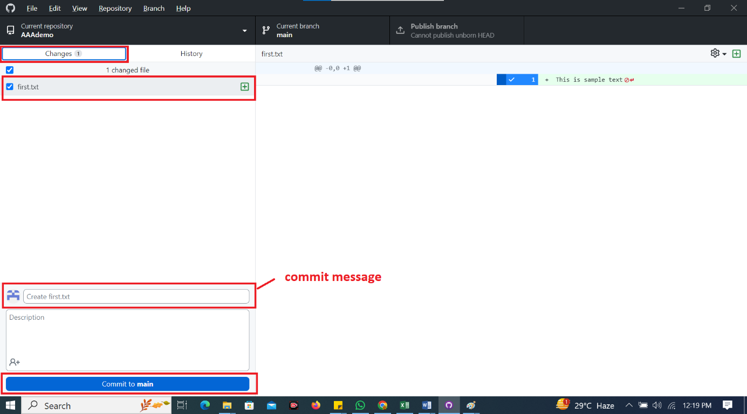

Push Changes to GitHub:

Click the "Publish branch" button in GitHub Desktop. This will upload your changes to the remote GitHub repository.

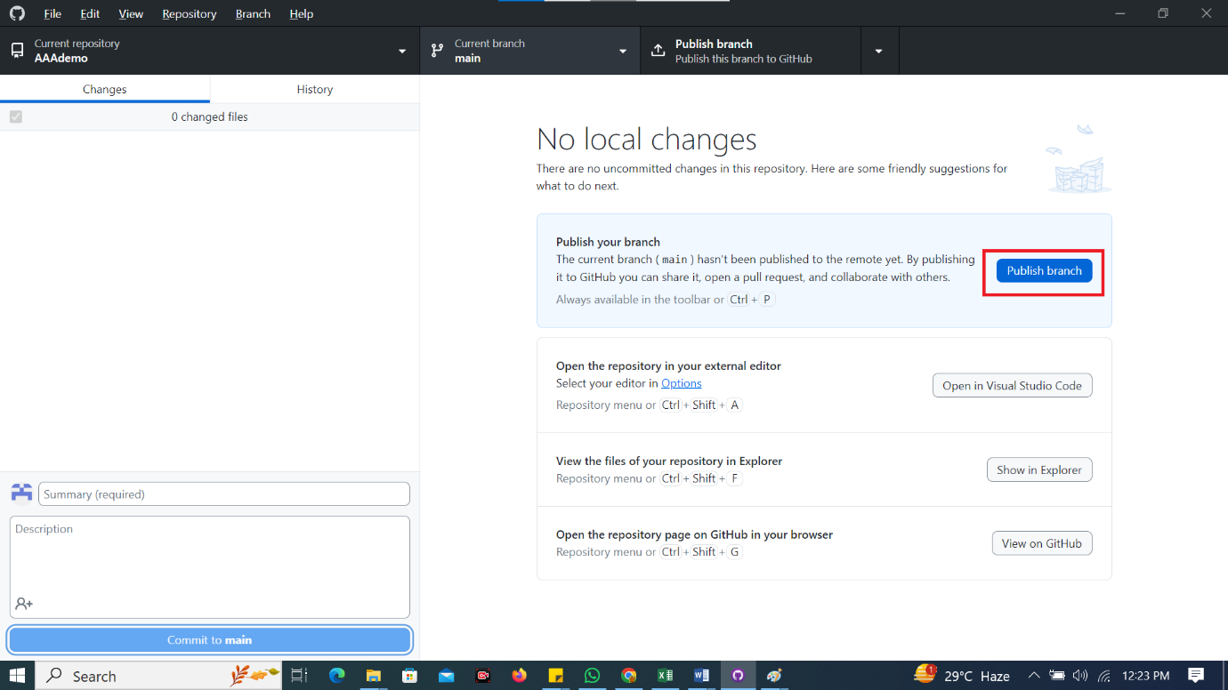

Verify on GitHub: Refresh your repository page on the GitHub website. You should see your changes reflected there.

